**STEPS FOR DISPOSAL OF PROPOSALS ON PSBloansin59minutes PORTAL**

1)Maker and checker ID’s have been created for branches , MSME Clusters and RAM clusters, user can logon by checker ID(mobile number and OTP or **email Id and** **password**) of branch using URL <https://www.psbloansin59minutes.com/sidbi> and taking appropriate action on the proposals displayed in checker profile.

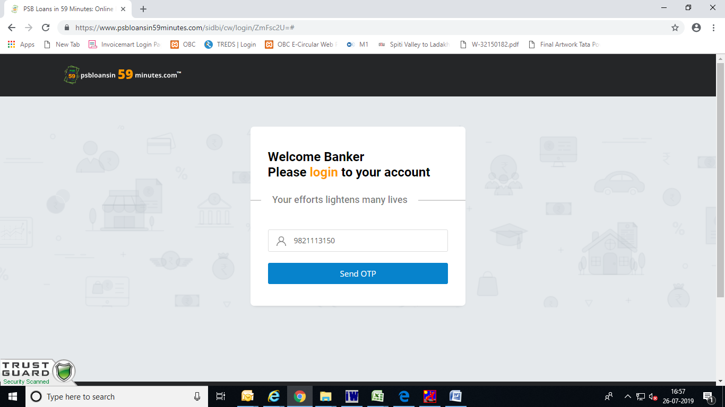

Put in your checker mobile number and click on send OTP, OTP will be sent to checker’s mobile number , put in the OTP and click on login.

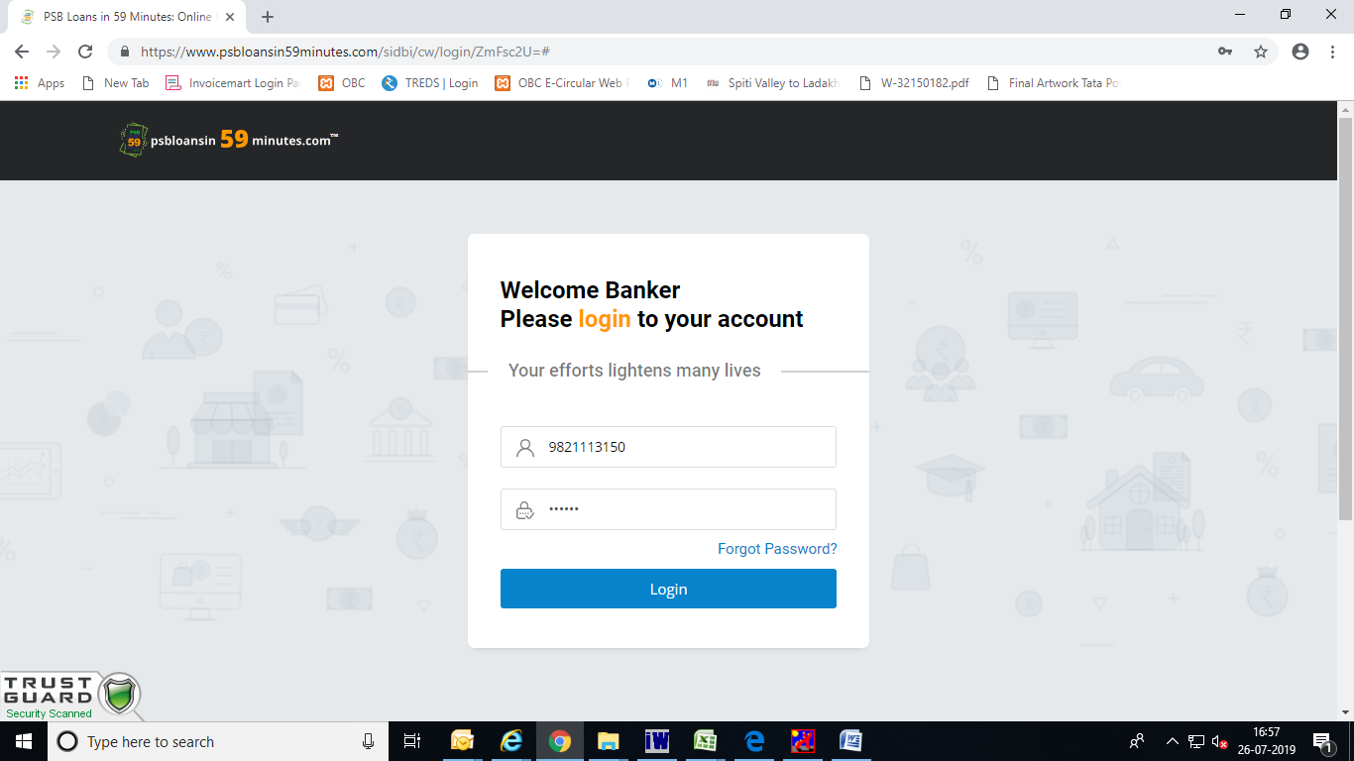

2)After login **Online proposals** will be reflected on the login page, click on the proposal and option will be displayed to update status of the proposal. 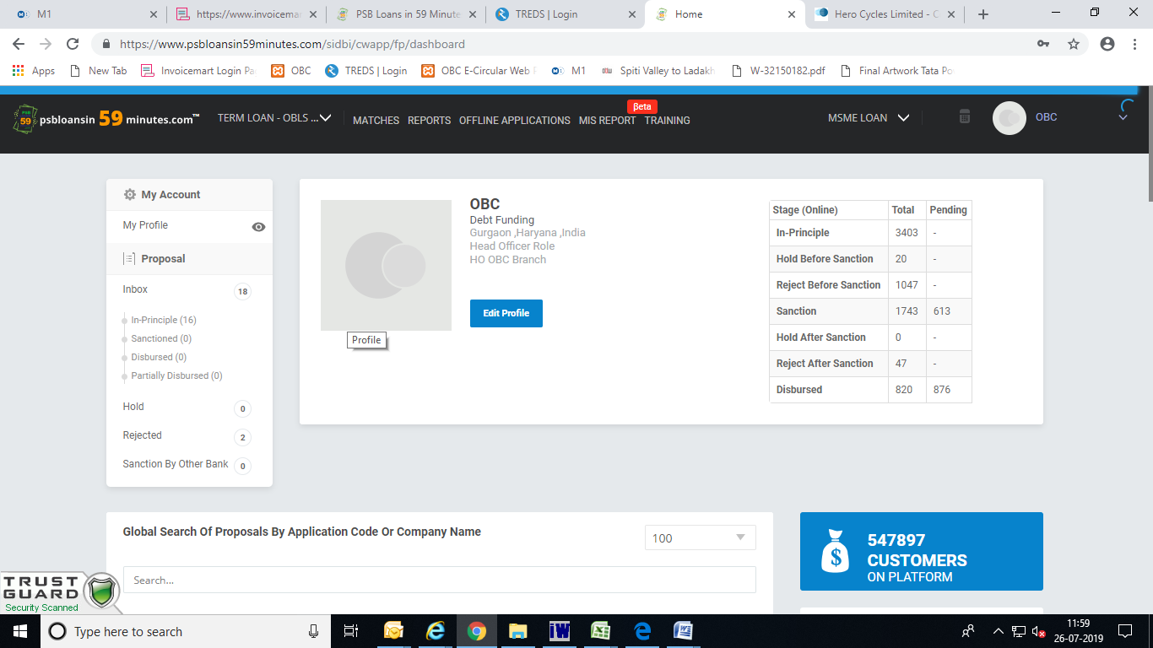

Scroll down

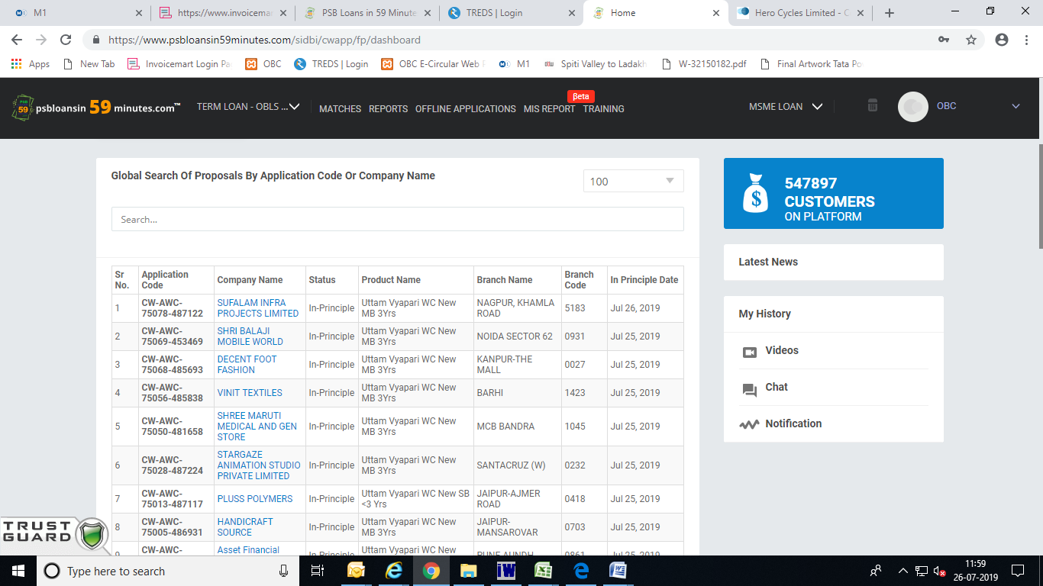

Click on the proposal and windows will open with option to Sanction/Hold and Decline the proposal

3)Offline proposals will be displayed after clicking on Offline applications option and option will be displayed for sanction/rejection and disbursement.

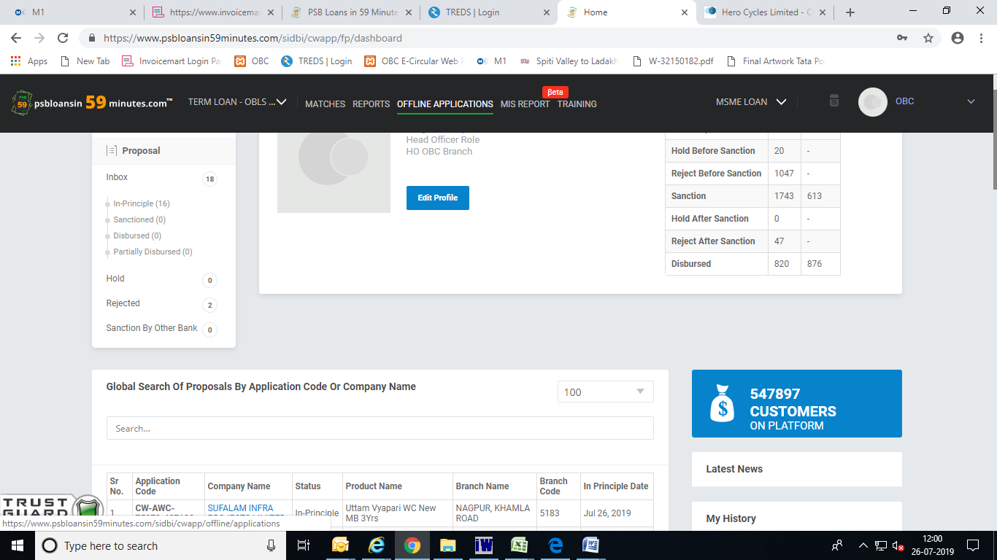

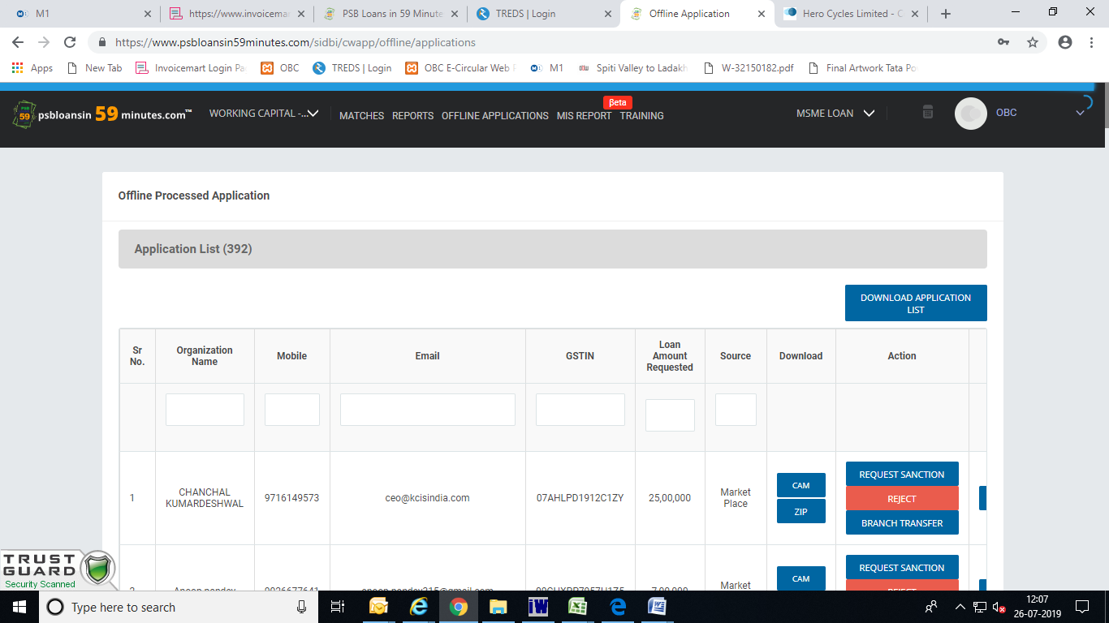

Click on sanction / rejection, give remarks and submit.